Analysis of the Yuka Mobile App

Design and Purpose
Yuka is a mobile app that allows users to make decisions about food and cosmetic products by scanning barcodes to view and check detailed product assessments. Yuka's main service is to assess the health impact of products based on their ingredients and nutritional values, so anyone can make healthier, safer choices. The app exists to make consumers aware and informed about what type of food products they should eat to lead them into a healthy lifestyle by providing transparent product information. The app is optimized for simplicity and clarity. When the user scans a product’s barcode, Yuka immediately shows the user a health score with color-coded indicators, green for good, orange for moderate, and red for poor, which communicate naturally to the user that a product is good. The neat interface and short nutrition and ingredient descriptions tell users this is a health-oriented app that's meant to assist with fast but informed decision-making.

User Needs Addressed
Yuka tackles several fundamental user requirements:
1. Consumers want credible, easy-to-interpret product health information about food or cosmetic products, and Yuka aims to do this by compiling scientific evaluations of ingredients and nutritional content.
2. Encouragement to purchase healthier options: As people look for personalized suggestions to switch to healthier substitutes, Yuka presents better alternatives by recommending healthier product substitutions when available.
3. On-the-go, convenient product evaluation: Users need a fast, mobile solution to assess products while shopping, and Yuka provides immediate results through barcode scanning that can be done in-store or at home.

Features Tailored to User Needs
The key features are an intuitive-to-use barcode scanner with a very quick response, a clear health score system integrated with ingredient breakdowns, and healthy options as proposed. The design of the app focuses on legibility with large fonts, color-coded scores, and easy navigation tabs where users scan history, favorites, and recommended items. They allow rapid decisions and on-demand product tracking.

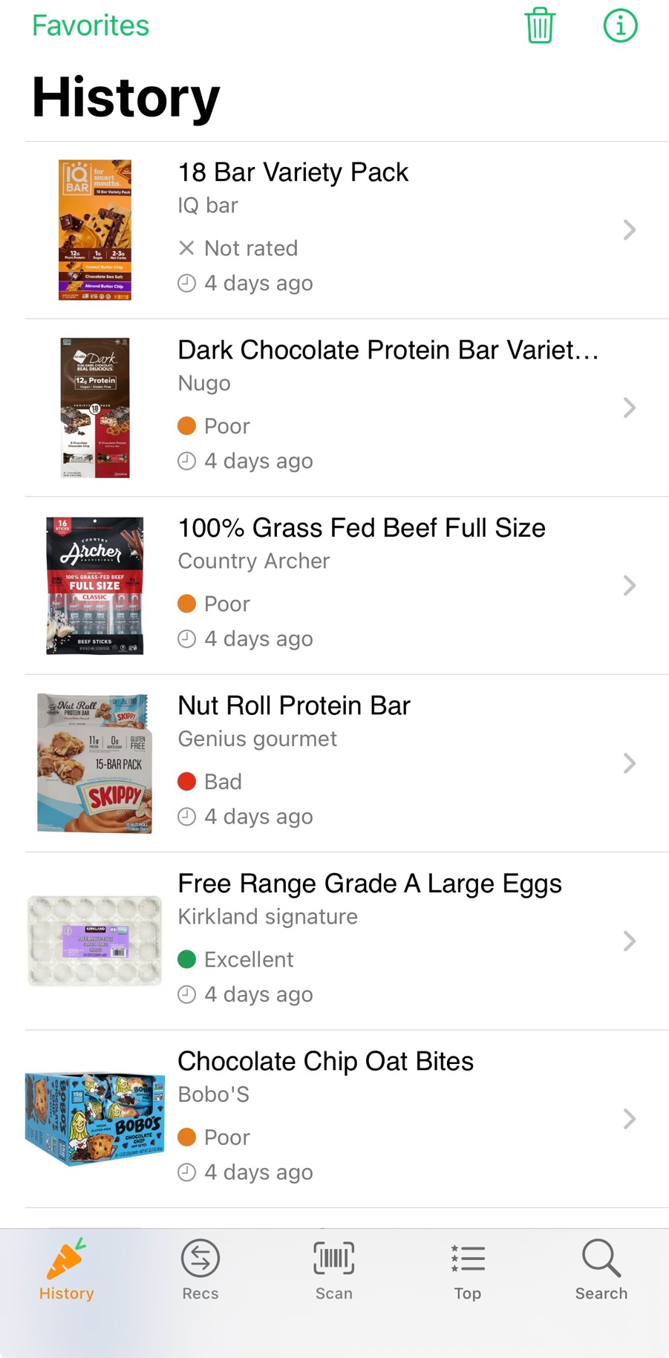
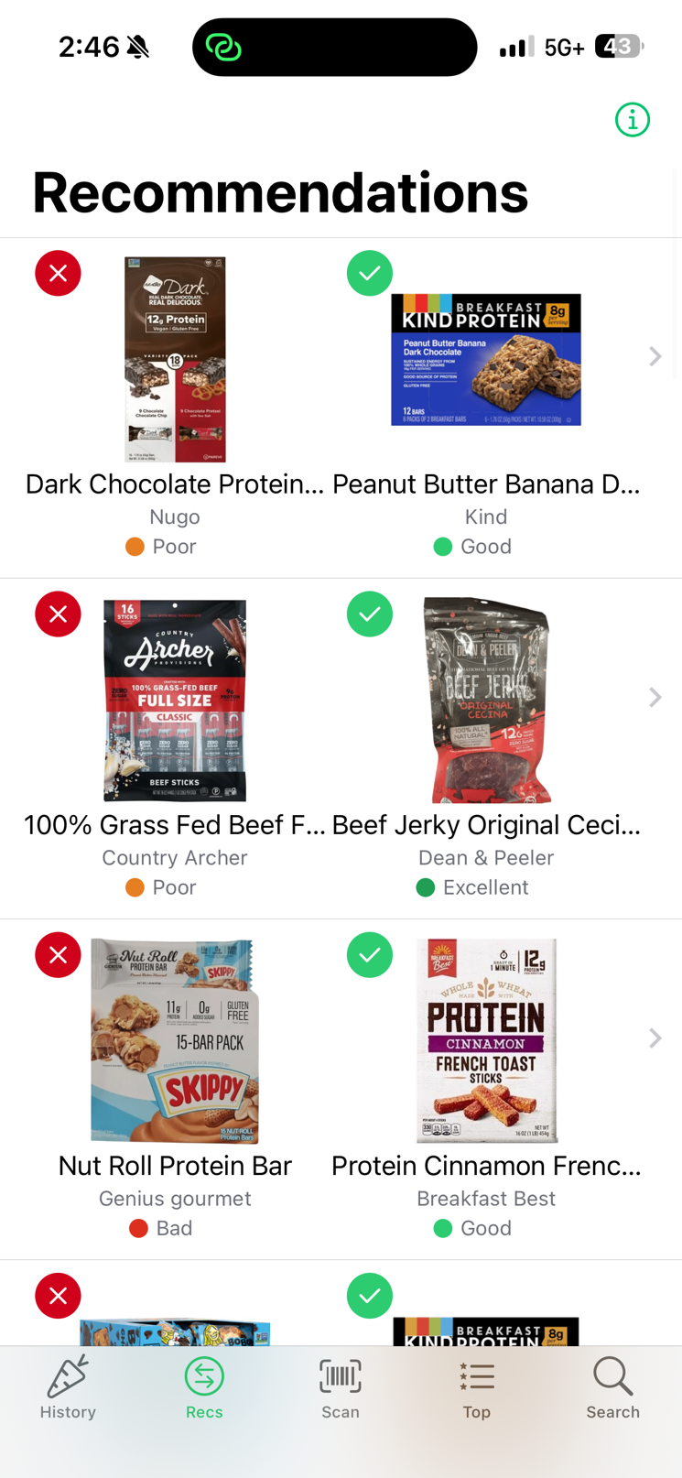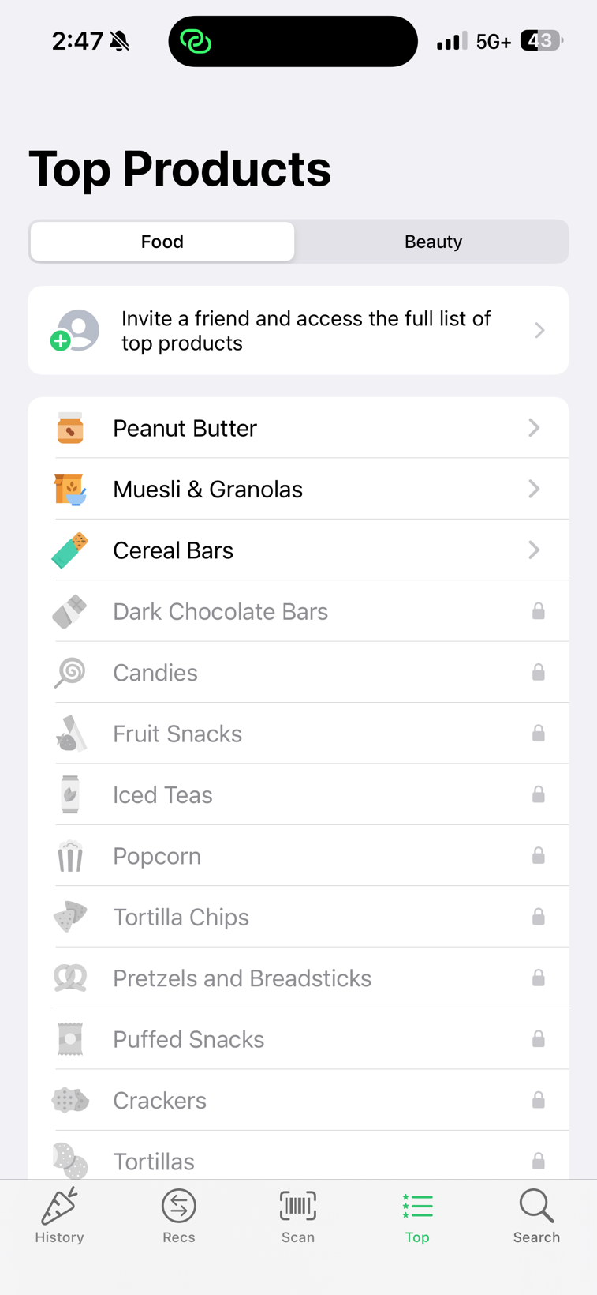
User Information Valuable for Development
The Yuka design requires a deep understanding of user characteristics, including by age range, diet (e.g., vegan or gluten-free), and so on, to make better product evaluations for individual users. Knowing user shopping behavior, scanning frequency, prevalent health issues (including allergies or intolerances), and ability to understand helps to personalize explanations and recommendations. Feedback on usability in stores would also inform scanning speed and offline operational options. It makes sure the app stays useful, trusted, and in tune with ongoing user health aspirations.

